JAMESTOWN

Their Struggle. Their Survival.

Significance: The founding of Jamestown, America’s first permanent English colony, in Virginia in 1607 – 13 years before the Pilgrims landed at Plymouth in Massachusetts – sparked a series of cultural encounters that helped shape the nation and the world. The government, language, customs, beliefs and aspirations of these early Virginians are all part of the United States’ heritage today.

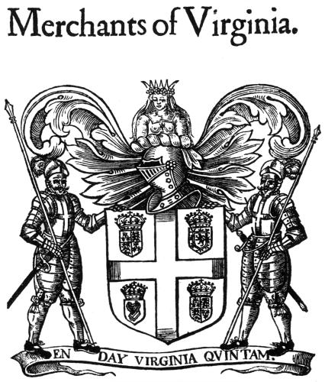
1607→ 22 years after the “Lost Colony of Roanoke,” colonists attempted to settle along the James River of Virginia in a new colony called Jamestown, named after the English King James 1.

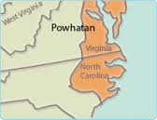
The site for Jamestown was picked for several reasons, all of which met criteria for the Virginia Company, a joint stock company who funded the settlement in order to make a profit off of the New World’s resources. Majority of the settlers were men. One of the leaders in the colony was the famous Captain John Smith, who had an extensive military background and a reputation as a brave and courageous warrior. He quickly took over the exploration of Virginia, making almost constant trips to explore the Chesapeake Bay, discover new rivers, and trade with the Indians for corn. As a result, Smith’s account does not say much about events within the confines of Jamestown. Smith later became the president of the colony and is generally credited with saving it from collapse.

The settlers began to succumb to a variety of diseases. Death tolls were high. They were drinking water from the salty or slimy river, which was one of several things that caused the death of many. They were dying from swellings, fluxes, fevers, by famine, and sometimes by wars. Food was running low, though then Chief Powhatan of a nearby Native tribe sent gifts of food to help the English. If not for the Powhatan Indians help in the early years, the settlement would most likely have failed, as the English would have died from the various diseases or simply starved.

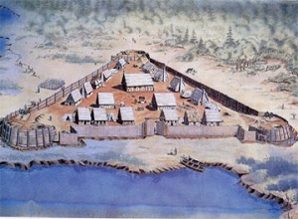
1609→ The relationship between the Powhatan Indians and the English had gone bad as the English were demanding too much food during a drought. That winter of 1609-10 is known as the "Starving Time." During that winter the English were afraid to leave the fort, due to a legitimate fear of being killed by the Powhatan Indians. As a result they ate anything they could: various animals, leather from their shoes and belts, and sometimes fellow settlers who had already died.

1610→ According to English writer and colonist William Strachey, most of the settlers, 80-90% had died due to starvation and disease.

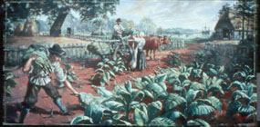
1612→ John Rolfe, a colonist sailing to Virginia with more supplies, helped turn the settlement into a profitable venture. He introduced a new strain of tobacco seeds. Tobacco was a cash crop for the Virginia Company and was a main reason why more English colonists came to settle in the colony.

1619→ Newly appointed Governor Yeardley called for the first representative legislative assembly, which was the beginning of representative government in America. In that same year, the first documented Africans were brought to Virginia because they needed human resources for the labor intensive tobacco. Also in this year, the Virginia Company shipped over 90 women to start families in order to make this a permanent colony.

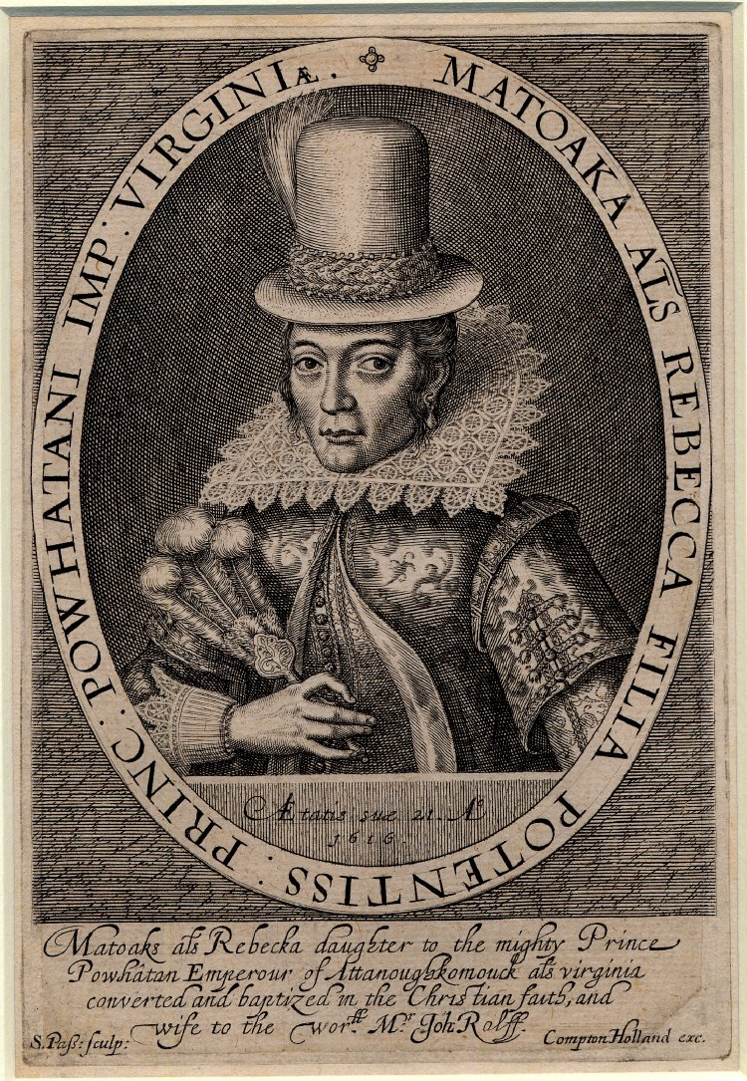
1622→ Peace between the Powhatan Indians and the English was brought about because of the marriage of Pocahontas (Rebecca Rolfe) and John Rolfe in 1614, but this ended in 1622. Pocahontas was “King” Powhatan’s daughter and a Native “Princess.” She was the first Native woman to visit England. Pocahontas presented to English society as an example of the Christian converted civilized “savage” in hopes of stimulating investment in the Jamestown settlement.

Tired of English advancement on Powhatan lands, paramount Chief Opechancanough planned a coordinated attack against the English settlements. Jamestown settlers escaped being attacked, due to a warning from a Powhatan boy living with the English. After the attack, Powhatan Indians withdrew and waited for the English to learn their lesson and leave. The English regrouped and fought back for over ten years.

1632→ Peace between Natives and English.

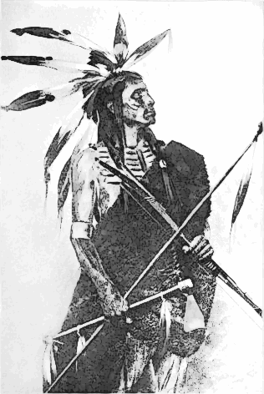
1624→ King James I revoked Virginia Company’s charter of Jamestown and it became a royal colony until the Revolutionary war. More settlers arrived.

1644→ Chief Openchancanough planned another attack. The attack ended when he was captured in 1646, taken to Jamestown, and shot. His death brought an end to Powhatan rule. His successor signed the first treaties with the English, which made the Powhatan Indians subjects of the English.

Primary Source Documents

Document 1: Reprinted from Travels and Works of Captain John Smith, President of Virginia, and Admiral of New England, 1610.

[Modern Version] The cruelty of the [Powhatans], the stupidity of our leaders, and the loss of our ships [when they sailed away] caused 440 of the 500 people in Jamestown to die ...

We still call this time the "Starving Time." What we suffered was too terrible to talk about and too hard to believe. But the fault was our own. We starved because we did not plan well, work hard, or have good government. Our problems were not because the land was bad, as most people believe.”

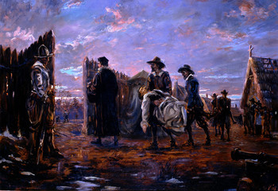

Document 2: McCartney, Martha. "The Starving Time." Encyclopedia Virginia. Virginia Foundation for the Humanities, 30 May. 2014. Web. 27 Oct. 2014.

“The Starving Time refers to the harsh winter of 1609-1610 when 3 quarters of the colonists at Jamestown died of starvation. George Percy, colonist during these times wrote, “the Englishmen felt the sharpe pricke of hunger which no man truly describe but he which have tasted the bitterness of it. An untold number of the English fed on the meat of their dead fellows.” Picture is of the Burial of the Dead 1609-1610.

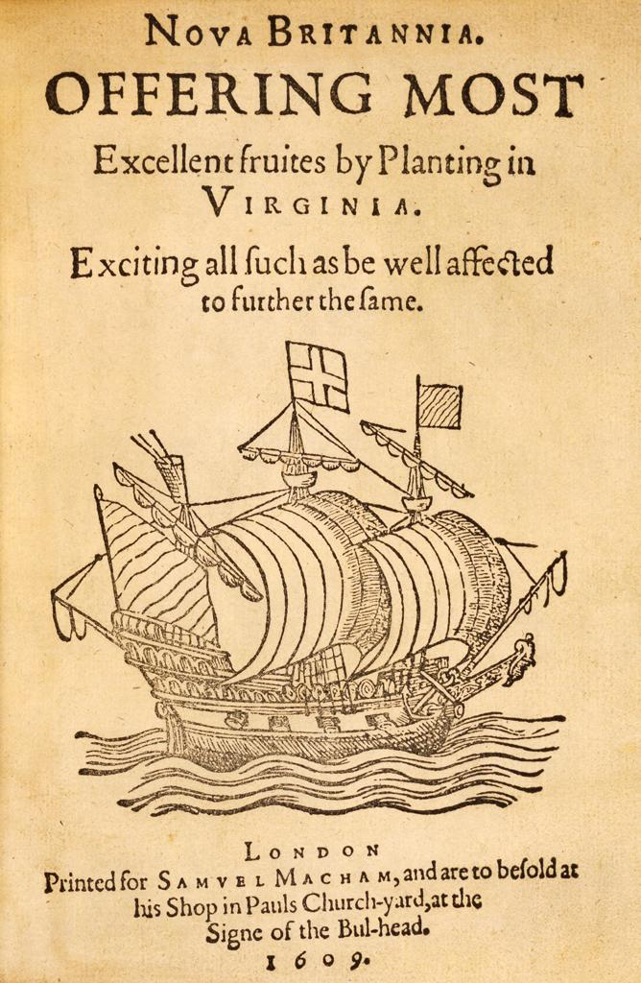
Document 3: Advertisement Promoting “New” England, 1609

Captain John Smith had a vision and a determination to make the settlement work. He and other soldier governors, quite literally ran the settlement with military discipline and ensured its survival against the odds. Although the settlement began with only men, the colony slowly grew as people, including women and children, were enticed to join the ‘New England’. Neither gold nor silver saved the Jamestown settlers, but tobacco. Plantations of tobacco sprang up along the banks of the James River and the settlement of Jamestown was assured.

ROANOKE VS. JAMESTOWN

DIRECTIONS:

1. TITLE: At the end of Roanoke presentation, create new title slide for Jamestown Colony→ First permanent English settlement in America. You may add a new slide to beginning of entire presentation titled “Roanoke VS. Jamestown.”

2. STRUGGLE: Describe the struggles of Jamestown. Why did they struggle? (use quotes from either primary or secondary source readings)

3. SURVIVAL: Describe how Jamestown survived. Why were they successful? (use quotes from either primary or secondary source readings)

4.COMPARISON: Although they experienced similar struggles, what did Jamestown do differently than Roanoke? In other words, why do you think Jamestown was more successful than the “lost colony”? Why did they come to the New World?

JAMESTOWN Sources:
http://www.nps.gov/jame/historyculture/a-short-history-of-jamestown.htm
http://web.wm.edu/hsi/cases/jamestown/jamestown_documents.htm#doc6
http://www.historyisfun.org/jamestown-settlement/history-jamestown/
http://www.smithsonianmag.com/ist/?next=/history/how-much-do-we-really-know-about-pocahontas-4206184/
http://www.intriguing-history.com/american-settlement-how-did-jamestown-colony-survive/

